**Date:21/8/19 IT204 Signals and Systems Lab**

**Exercise 1**

Write a MATLAB program to compute Fourier series of the following periodic signals

(a) Square Wave

(b) Sawtooth Wave

(c) Triangular Wave

Find the Fourier Coefficients. Plot the amplitude and phase spectrum

**Exercise 2**

For the full-wave rectifier waveform shown in Figure, the period is 1/60 s and the amplitude is 169.71 Volts.

(a) Write a MATLAB program to obtain the exponential

(b) Fourier series coefficients cn for n = 0,1, 2, .. , 19

(b) Find the dc value

(c) Plot the amplitude and phase spectrum.

**Exercise 3**

Consider the following discrete-time signals with a fundamental period of 6

x[n] = 1 – cos($\frac{2π }{6}$ n)

(a) Determine the Fourier series coefficients. Plot the magnitude and phase of each coefficients

**Exercise 4**

**Simulink**

Environment for graphical, model-based simulation of dynamic systems

**Starting Simulink**

* Run MATLAB first
* Type in the Control Line Window
* >> simulink
* or …
* Click on the Simulink icon in the MATLAB toolbar
* You must be running Simulink now

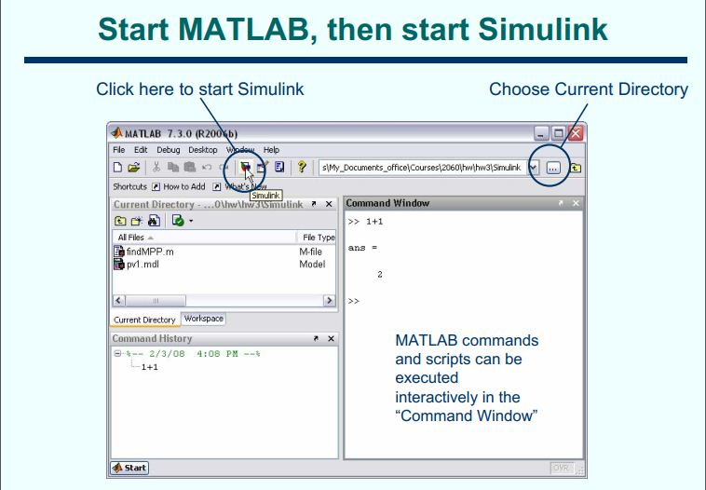

**Simulink Libraries**

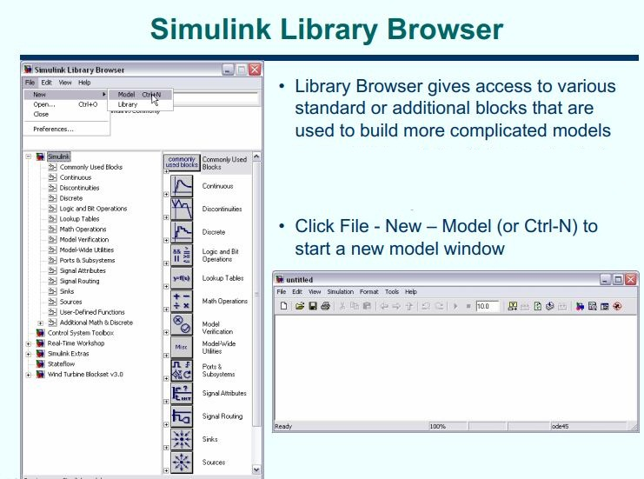

**Creating a model:** File->New->Model  
**Saving a model:** File->Save As <modelname>.mdl

**Exercise 1:** Design a continuous system using sine wave

**Block diagram**

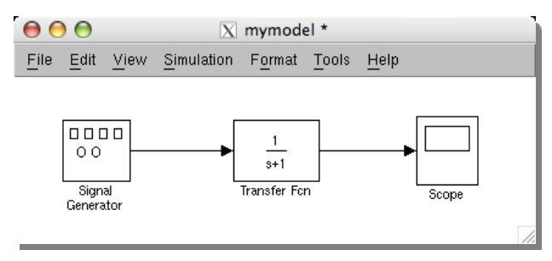

* Drag and drop Sine Wave block from Sources in the Library to your model window
* Drag and drop Transfer function from Continuous in the Library to your model window
* Drag and drop Scope block from Sinks in the Library
* Connect block inputs and outputs according to the circuit equation.

Double-click a block to change parameter values. To better document the model, double-click on the block name or on the connection line to change block and signal names as desired

**Block parameters**

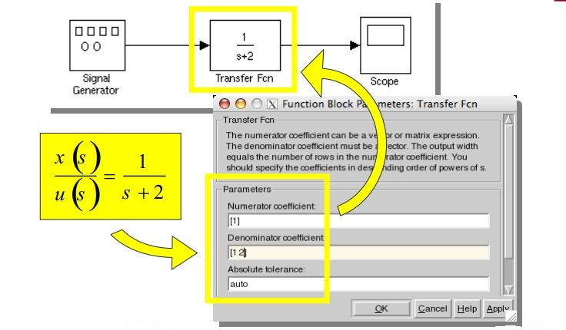

Double-click on the Scope block to display the output waveform

**Exercise 5**

Generate the following signal wave forms using Simulink

(a) Sawtooth signal

(b) Sine signal

(c) Square